Write a command using ls to list all files (including hidden files) in the current directory and its subdirectories.

Modify the previous command to display only files with a specific extension (e.g., .txt).

Enhance the report by including the file size for each listed file.

Further refine the output to display only files modified within the last 24 hours.

Combine the functionalities from points 2 and 4 to list only files with a specific extension (e.g., .jpg) modified in the last day.

Commands:

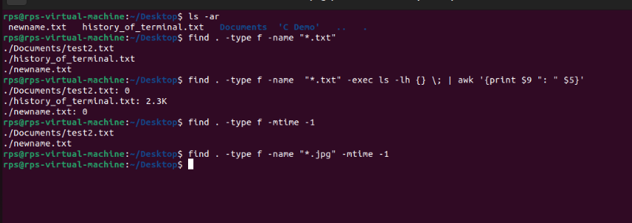

Explanaton:

1. ls -aR: Lists all files and directories, including hidden ones, recursively.
2. find . -type f -name "\*.txt": Finds all files (-type f) with a .txt extension starting from the current directory (.).
3. find . -type f -name "\*.txt" -exec ls -lh {} \; | awk '{print $9 ": " $5}': Finds all .txt files and uses ls -lh to display file details, then awk extracts the file name and size.
4. find . -type f -mtime -1: Finds all files modified in the last 24 hours (-mtime -1).
5. find . -type f -name "\*.jpg" -mtime -1: Combines both conditions to find .jpg files modified in the last day.